

**Population Census Application**

**Software Requirement Specification (SRS) Document**

**Sprint 2 Implementation**

**Project Timeline: 07.09.2022 to 25.09.2022**

**INDEX**

1. Introduction

1.1 Purpose -------------------------------------------------- 4

1.2 Intended audience -------------------------------------------------- 4

1.3 Intended use -------------------------------------------------- 4

1.4 Scope -------------------------------------------------- 4

2. Overall description -------------------------------------------------- 5

2.1 Assumptions and dependency -------------------------------------------------- 5

3. System feature and requirements -------------------------------------------------- 6

3.1 Functionality -------------------------------------------------- 6

3.1.1 Dynaland Zone Wise Registration Module -------------------------- 6

3.1.1.1 Zone 1 Citizen Register function ---------------------------6

3.1.1.2 Zone 2 Citizen Register function ---------------------------6

3.1.1.3 Zone 3 Citizen Register function ---------------------------6

3.1.2 Dynaland Central Government Module -------------------------- 6

3.1.2.1 Citizen Data Modify function ---------------------------6

3.1.2.2 Citizen Data Delete function ---------------------------6

3.1.2.3 Citizen Data View function ---------------------------6

3.1.2.4 Age Group Reportfunction ---------------------------6

3.1.2.5 Gender Report function ---------------------------6

3.1.2.6 BPL Zone Wise Report function ---------------------------7

3.1.2.7 Farming Population Report function ---------------------------7

3.1.2.8 Literacy Rate function -------------------------7

3.1.2.9 Zone with Highest Literacy Rate function -----------------------7

3.1.2.10 BPL Average Income function -------------------------7

3.1.2.11 Rural and Urban Population function --------------------------7

3.1.2.12 Zone with highest Male and Female function ---------------------7

3.2 System requirement -------------------------------------------------- 7

3.2.1 Tools to be used -------------------------------------------------- 7

3.3 System feature -------------------------------------------------- 8

4. DataFlow Diagram

4.1 DFD level 0 ------------------------------------------------ 8

4.2 DFD level 1 ------------------------------------------------ 9

### **1.** **Introduction: -**

The introduction of the software requirement specification provides an overview of the entire software. The entire SRS with overview description purpose, scope, tools used and basic description. The aim of this document is to gather, analyse and give an in-depth .so in Dynaland is a country with population of around 20 crore.Earlier they used to have a population census every 4 years which has completely manual.The reports were taking a lot of time to be compiled and generated.Also that the govt.since they have the census coming up after 6 months they have decided to automate the system.

**1.1** **Purpose**: **-**The purpose of this document is to show the requirements for the Dynaland Automated Population Census Application , which helps in census of population Automated because of more population in Dynaland country they decided to census the population for every 4 years which was completely manual. The reports were taking a lot of time to generate so decided to things become easier to census population fastly so decided to census coming up after 6 months to automate the system.which will help them in Getting timely and correct reports. save time and money for the process of planning for the welfare of people through the correct data.

1 **.2** **Intended Audience: -**This document is intended to be read by, Client.

**1.3** **Intended Use:**

* Development Team
* Maintenance Team
* Clients

Since this a general-Purpose Software any one can access it.

**1.4** **Scope: -**This project aims to create the Reports of Dynaland Automated Population Census Application. In which the Government should prepare reports about the census population Automatically . This saves time and money in the census population. so introduced an Automated concept to easily census the population.

**2. Overall Description: -**

The Population Census application is a system that is designed to replace the traditional and manual way of generating reports for the country of Dynaland by automating the whole process of collecting and processing the data in a much more efficient and time saving way.

Where related information about a person would be stored and processed based on which zone the person belongs to. The control of this system will be divided into different zones responsible for registering citizens whereas the superior command will reside with the Centre who has all the authority of the system.

The Automated population census application will work in two main modules. The first module will be the citizen registration portal which will work at zone ends with the help of which, separate zones will be able to register the citizen and add their records to the data.

The second module of the system resides with the Central Administration which has total control over the system and can access any data from all three zones as well as perform other operations on the data. Only authorised persons can access the data through the central portal.

After successful authentication of the administrator, he has the authority to modify the records of the citizens, delete the records of the citizens as well as view overall data about the citizen. This gives flexibility to the authority in command to make sure the information being added into the database for every citizen is accurate as these data would further be used to generate reports. The administrator can also segregate information based on the data accumulated from each of the three zones. Using this data, reports can be generated and displayed by categorising specific fields present inside the data on the basis of citizens belonging to different zones. Such as reports of % of age groups present inside a zone, % of male and females present, % of rural population and urban population residing, zone wise reports for people below poverty line , average income of below poverty line people etc. The Admin can also work with queries that will be taken in as an input and return with suitable information of the citizens information as an answer to those queries. Such a query on literacy rate will be answered as to which zone has the highest literacy rate or which zone has the most male and female population respectively.

**2.1 Assumptions and Dependency: -**

* System should have Ubuntu Linux installed.
* · System should have either 4GB or more RAM.
* The service is used preferably on a desktop or laptop.

**3.System Features and Requirements: -**

**3.1 Functionality: -**

**3.1.1 Dynaland Zone Wise Registration module:** This module is used to register the citizens of the dynaland of various zones. Registration of the citizens done by the zone representatives.

**3.1.1.1 PCA-01: Zone 1 Citizen Register:** Details of each person in zone 1 entered based on their zone-id and ssid. Both will be unique.The data entered will include details like ssid, name, age, sex, address,qualification, occupation, annual income, no_of_dependants, rented house or own house, urban or rural etc.

**3.1.1.2 PCA-02: Zone 2 Citizen Register:** Details of each person in zone 2 entered based on their zone-id and ssid. Both will be unique. The data contains the personal details as mentioned in above para.

**3.1.1.3 PCA-03: Zone 3 Citizen Register:** Details of each person in zone 3 entered based on their zone-id and ssid. Both will be unique. The data contains the personal details as mentioned in above para.

**3.1.2 Dynaland Central Government module:** To access this module the representatives of the Central Government have to be authenticated by using password. They are also able to view the reports and can ask queries.

**3.1.2.1 PCA-04: Citizen Data Modify:** Central Government representatives by using this function can modify the data of the citizen.

**3.1.2.2 PCA-05: Citizen Data Delete:** Central Government representatives by using this function can delete the data of the citizen.

**3.1.2.3 PCA-06: Citizen Data View:** Central Government representatives by using this function can View the data of the particular person by entering his personal ssid number.

**3.1.2.4 PCA-07: Age Group Report:** This function will produce the report which will show the percentage of people between the age 1 to 17, 18 to 40 and more than 40 with respect to each zone as well as with respect to the whole country. This function is only accessible by central government people.

**3.1.2.5 PCA-08: Gender Report:** This function will produce the report which will show the percentage of male and female citizens with respect to each zone as well as with respect to the whole country.

**3.1.2.6 PCA-09: BPL Zone Wise Report:** This function will produce the report which will show the percentage and number of people below poverty line (below annual income of 1,00,000)with respect to each zone as well as with respect to the whole country.

**3.1.2.7 PCA-10: Farming Population Report:** This function will produce the report which will show the percentage of citizens having occupation as a farmer with respect to each zone as well as with respect to the whole country.

**3.1.2.8 PCA-11: Literacy_Rate:** By using this query the representative of the central government will be able to view the percentage of the literate population of the country.

**3.1.2.9 PCA-12: Zone with Highest Literacy Rate:** By using this query the representative of the central government will be able to know which zone is having the highest number of literacy rate.

**3.1.2.10 PCA-13: BPL Average Income:** By using this query the representative of the central government will be able to know the average annual income of the below poverty level people.

**3.1.2.11 PCA-14: Rural and Urban Population :** By using this query the representative of the central government will be able to know the percentage of people living in the urban and rural areas.

**3.1.2.12 PCA-15: Zone with highest Male and Female :** By using this query the representative of the central government will be able to know which are the zones having the highest number of males and females.

**3.2 System Requirements: -**

### **3.2.1. Tools to be used:**

* Pthread Library
* CPP Check
* CPP Unit
* Valgrind
* Strace

### **3.3 System Features: -**

### Supportability:The system is easy to use.

* Design Constraints: The system is built using only C++ language.
* Usability:
* Reliability & Availability**:** The system is available 24/7 that is whenever the user would like to use the system, they can use it up to its functionalities.

### Performance: The system will work on the user’s terminal**.**

**4. DataFlow Diagram:**

**4.1 DFD Level 0 -**

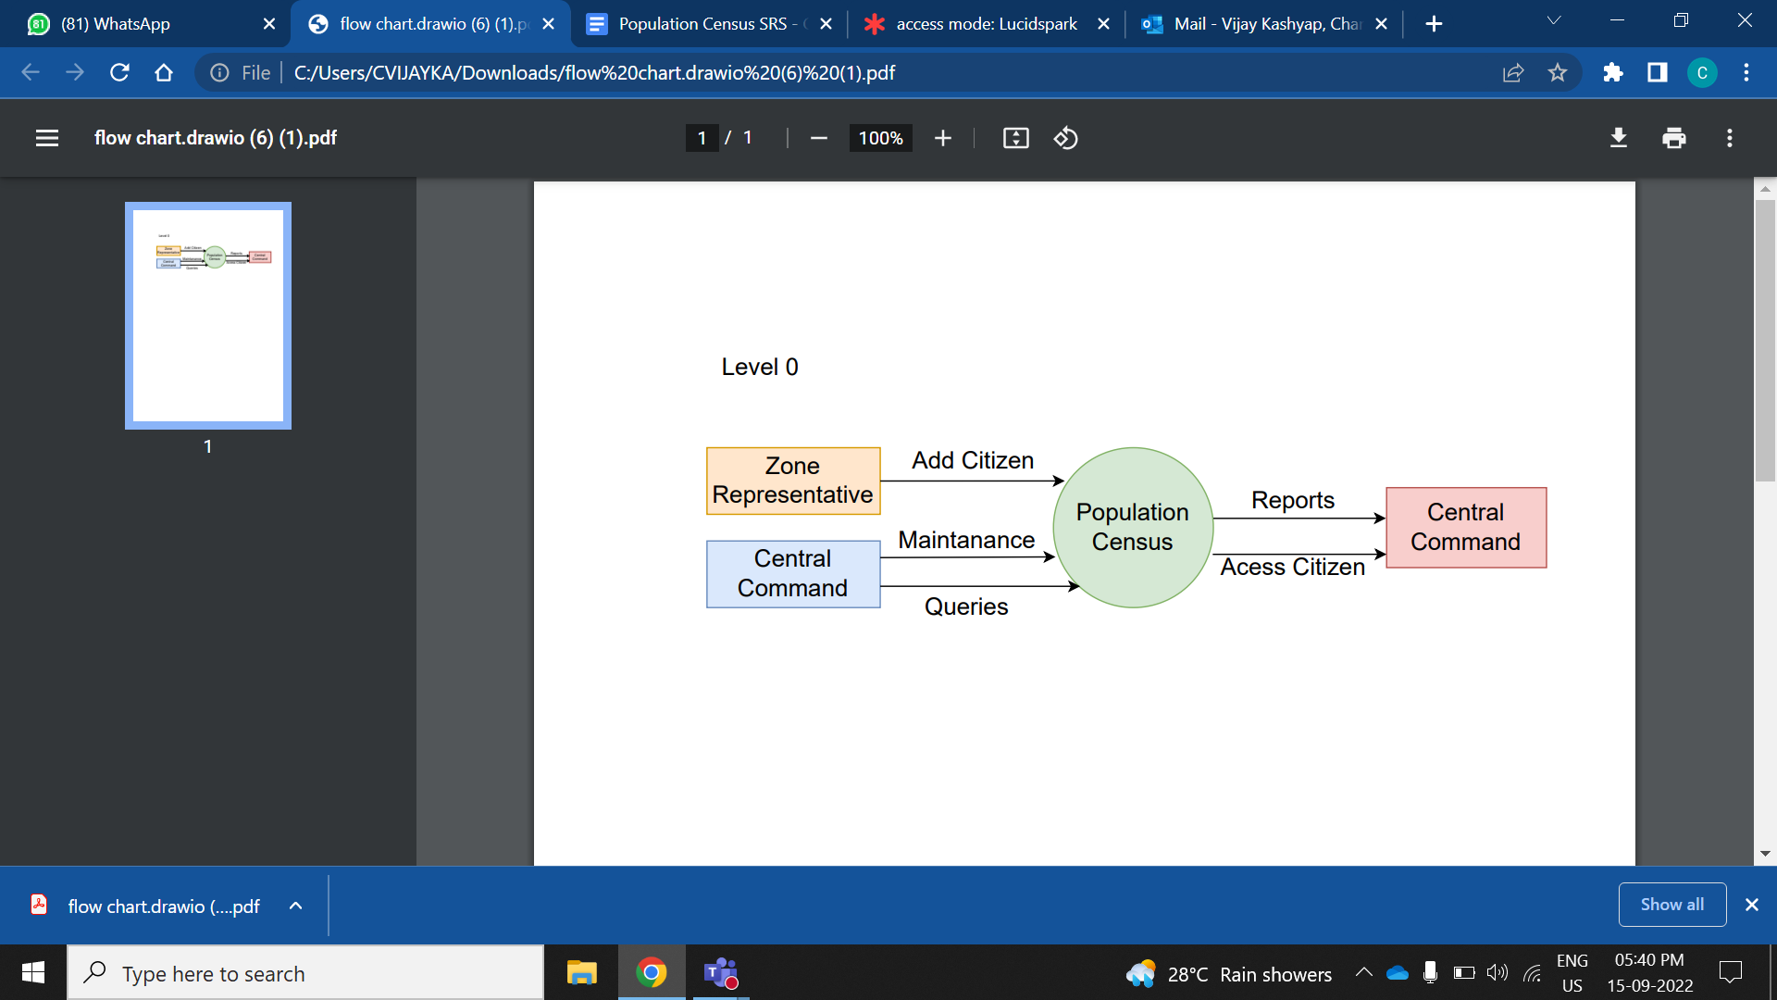

**4.1 DFD Level 1 -**

